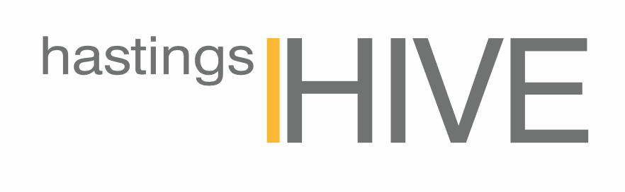
OUR KITCHEN RULES!

PLEASE DO:
- Put all dirty dishes in the dish-drawers - please don’t leave them in the sink or on the bench. The dish drawer with the 😊 magnet is the one to fill.
- If a dish-drawer is full, unwrap and place a tablet in the cutlery basket and set to normal wash. Then shift the 😊 magnet to the empty one (you might need to empty it first!) so others know which one to fill.
- Bring your snack/lunch for the day in a re-usable plastic container with your name on it and place in either fridge.
- Put dirty tea towels in the laundry basket (in the usability bathroom) and replace with fresh one from the second drawer on the right-hand side of the island bench.
- Use the Cafe area for eating, and wipe down the table/bench if you make a mess. No food to be consumed in the meeting rooms, i-office or i-desk spaces please. Drinks are OK in these areas.
- Rinse or wash any recycling before placing in the recycling station. Clean paper and cardboard can go in the paper bin at the printer station.

HANDY HINTS:
- All appliance manuals are in the second drawer on the left-hand side of the island bench.
- The Nespresso machine does frothy milk but the straw and nozzle need frequent cleaning in the dish-drawer. Microwaving your milk before adding your coffee is easier and just as good!
- If the sparkling water isn’t working the gas will have run out - please inform the Community Manager if this happens.
- Our cleaners use blue cloths in the kitchen and pink in the bathroom - please keep to the same system.
THANK YOU 😊

