Facility Reservation System
Monitor

- Connect your laptop to the appropriate port in the multiplug power box on the table in the meeting room (for the Boardroom and Meeting Room 1. For Meeting Room 2, connect directly into the tv monitor). USE YOUR OWN CONNECTION CABLES FOR THIS.

- Connect the audio speaker to your laptop using the USB cable provided. Push the button in the centre of the audio speaker to turn it on/off.
- Open your Zoom account.

- Start your call or meeting.
- Select the small green shield icon at the top left of your screen to open the Settings.

- Choose Video.
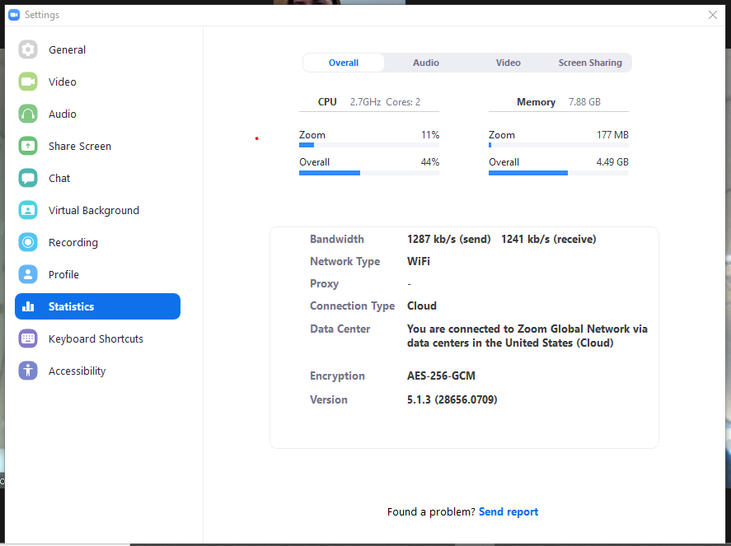

- Select the Logitech Meetup camera option in the drop-down list.

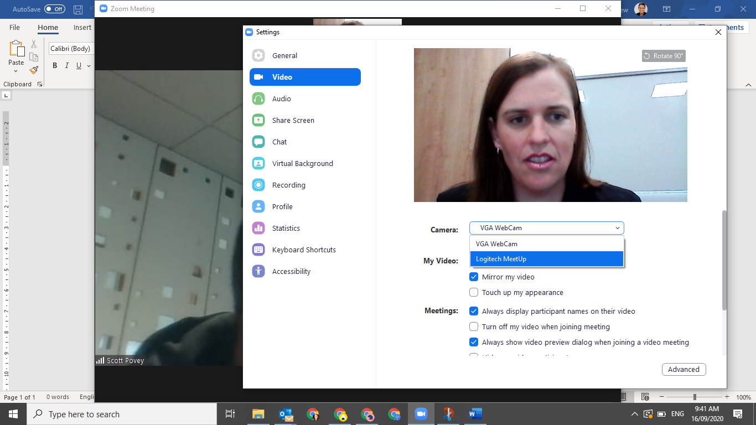

- Repeat the process for Audio (which should include Speaker and Microphone options, as below. Select the Echo Cancelling options in the drop down menus for each.

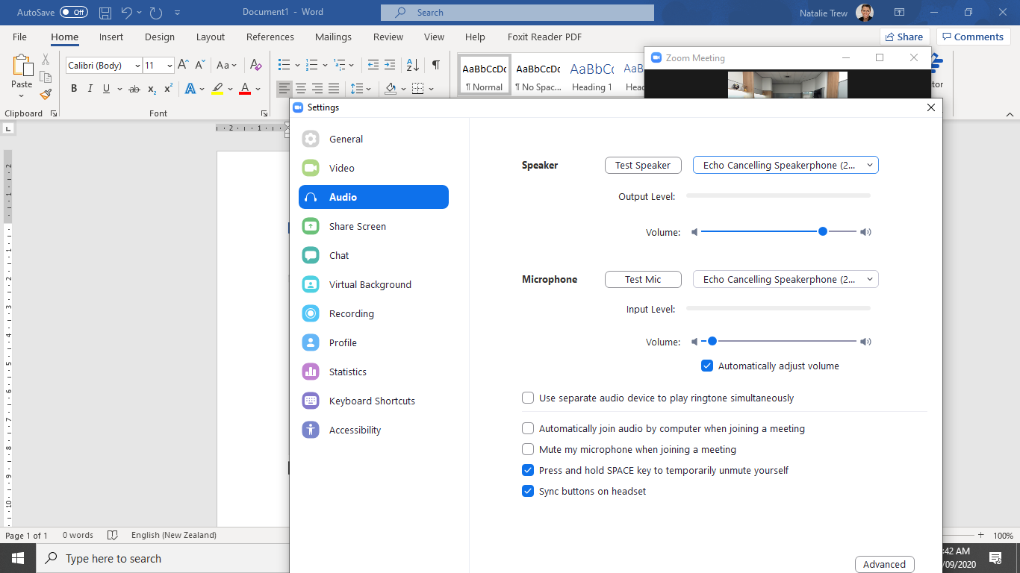

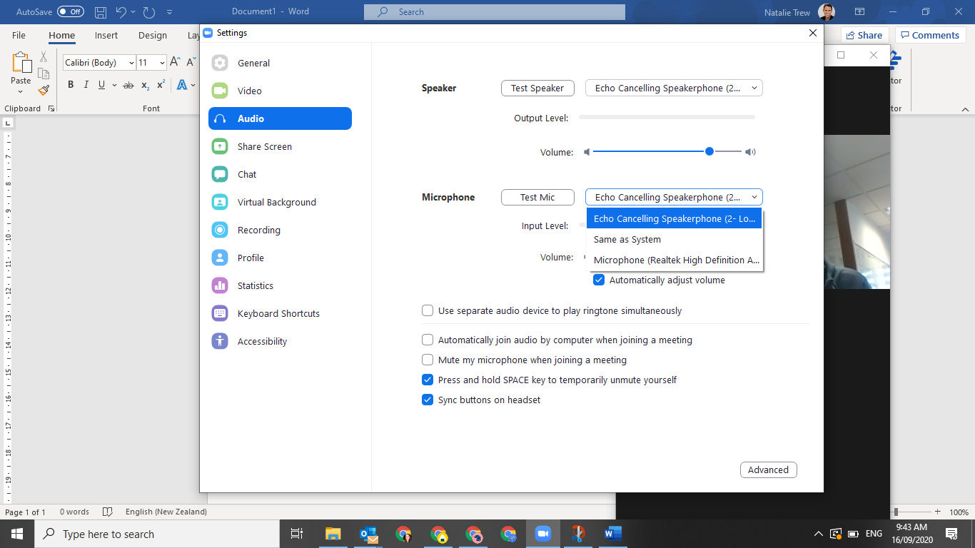

- The whole room should now be visible on the call. The camera and audio can be controlled using the square remote device that looks like this:

Things to note:

- At the moment, you need to provide your own HDMI cable or appropriate connection cable from your laptop device to the central port in the table (for the Boardroom and Meeting Room 1). Meeting Room 2 has no central port in the table so just connect your own cable to the tv monitor directly.

- Please tidy the cables away (use the Velcro cable tidy strap) when finished using the equipment.

Logitech Meetup Video Conference System Instructions for
Teams

- Connect your laptop to the appropriate port in the multiplug power box on the table in the meeting room (for the Boardroom and Meeting Room 1. For Meeting Room 2, connect directly into the tv monitor). USE YOUR OWN CONNECTION CABLES FOR THIS.

- Connect the audio speaker to your laptop using the USB cable provided. Push the button in the centre of the audio speaker to turn it on/off.
- Open your Teams account.

- Start your call or meeting.

- Click on your account image in the top right corner and select Settings.

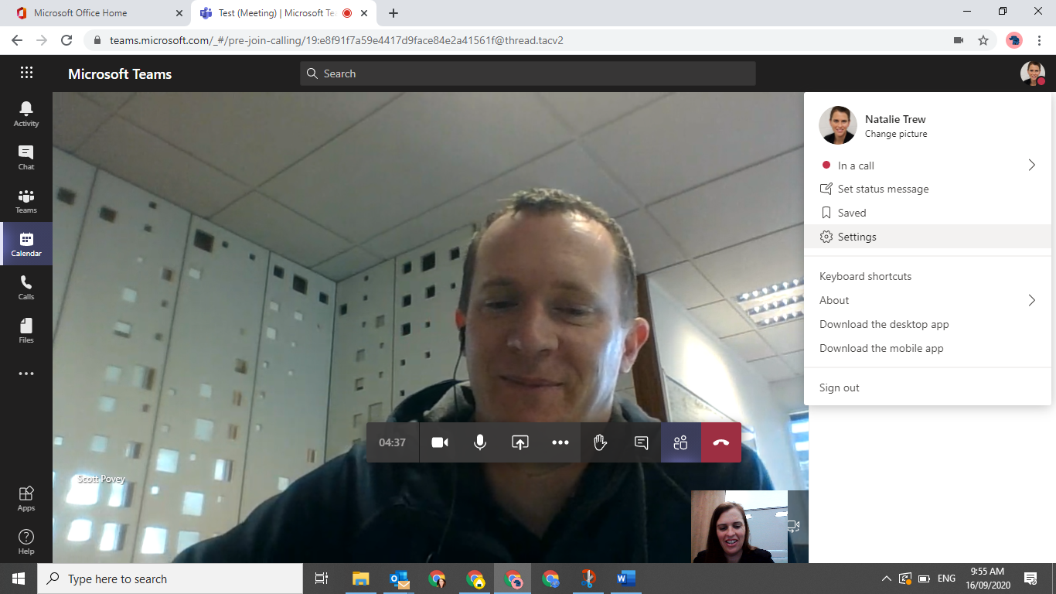

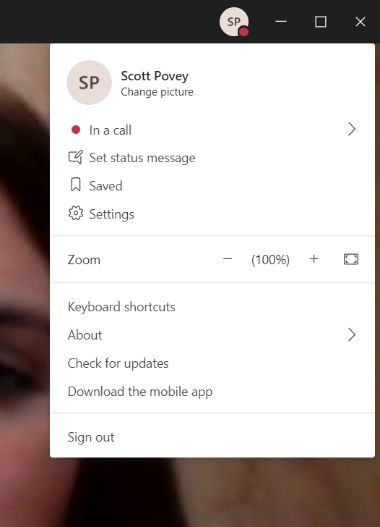

- Select Devices.

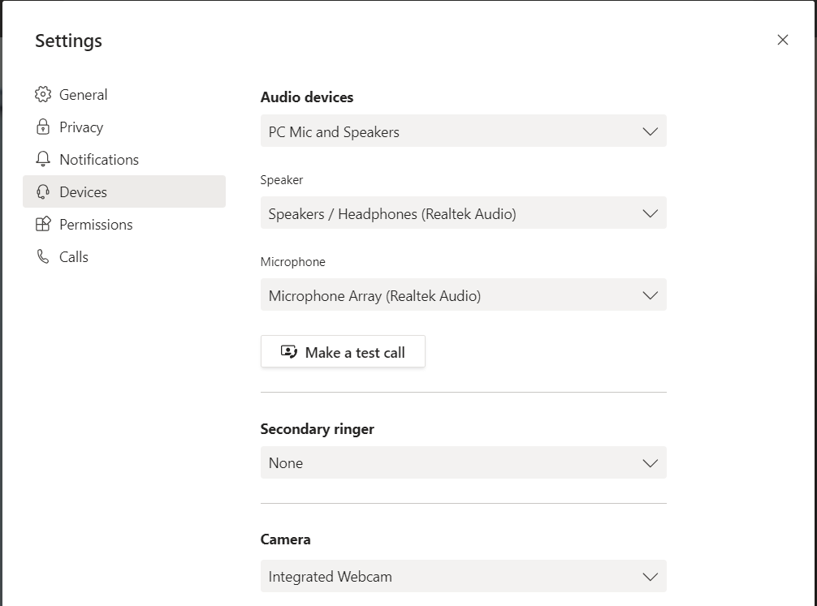

- Change the camera to the Logitech Meetup camera.
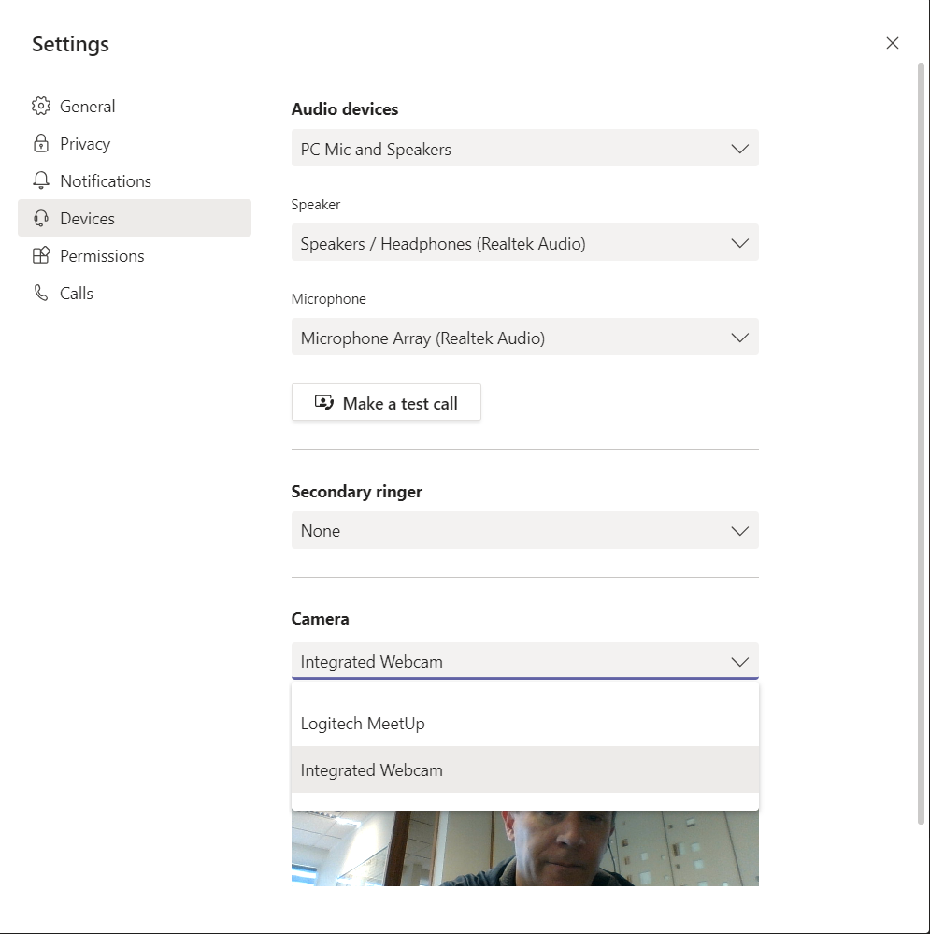

- Change the audio device to the Logitech Meetup device (Echo Cancelling).

- The whole room should now be visible on the call. The camera and audio can be controlled using the square remote device that looks like this:

Things to note:
- At the moment, you need to provide your own HDMI cable or appropriate connection cable from your laptop device to the central port in the table (for the Boardroom and Meeting Room 1). Meeting Room 2 has no central port in the table so just connect your own cable to the tv monitor directly.

- Please tidy the cables away (use the Velcro cable tidy strap) when finished using the equipment.

